Elastic File System

Mount Elastic File System (EFS) on EC2
Amazon EFS is a fully managed, scalable file storage service designed to provide shared access to files across multiple Amazon EC2 instances. It is particularly useful for applications and workloads that require shared file storage in a cloud environment.

Steps for EFS
- Create security group
- Create EFS
- Create instances(ec2) in howmany availability zones u need to share the file.
- We sharing the file in 3 availability zones.so we need to create 1 instances in each availability zone
CREATING THE SECURITY GROUP.(SG-Efs)

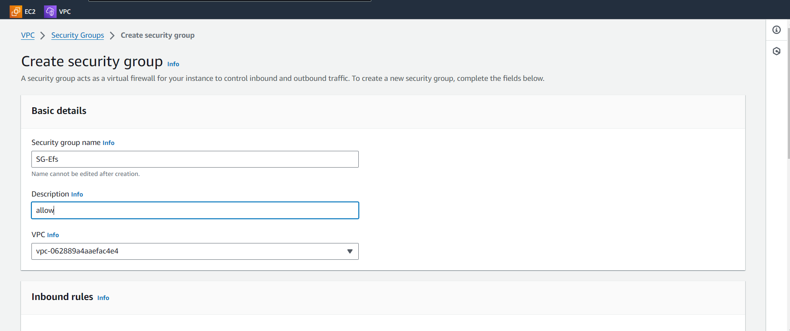

Attaching the all traffic and SSH in the inbound rules and click on the save changes.
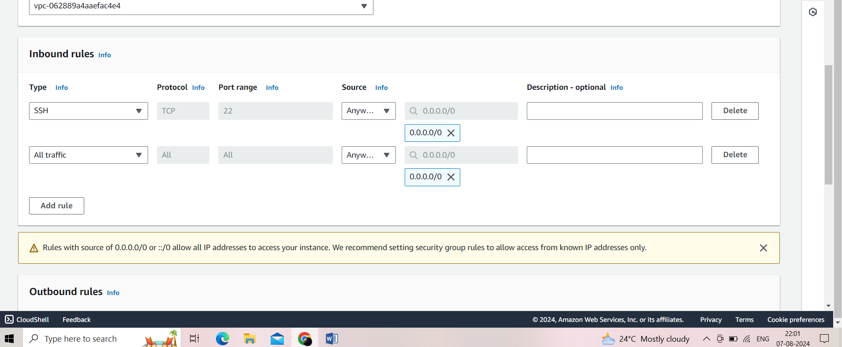

Security group is created
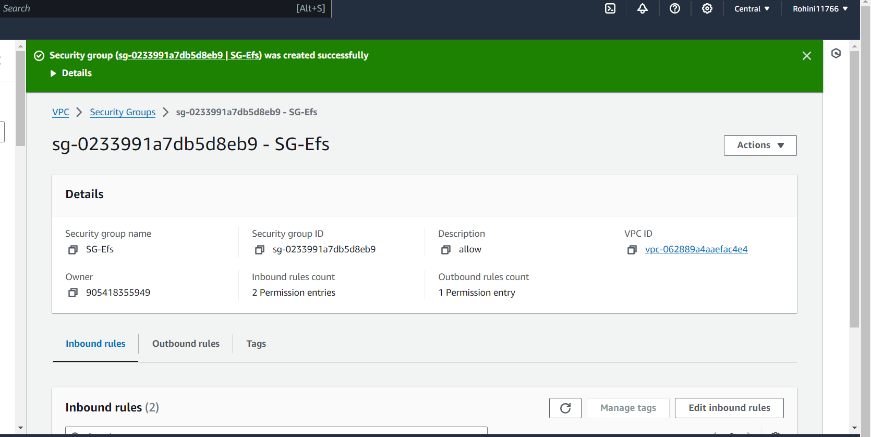

Creating the EFS
Click on create Efs
Name given as task

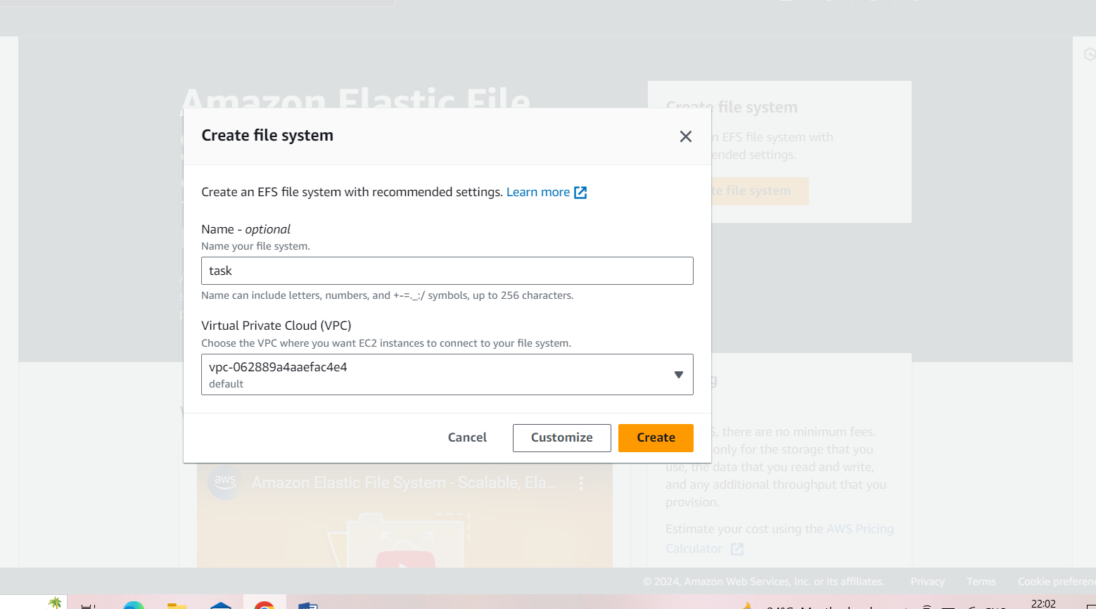

Click on customize
Select regional . Next next select the security group created alreadynextcreate
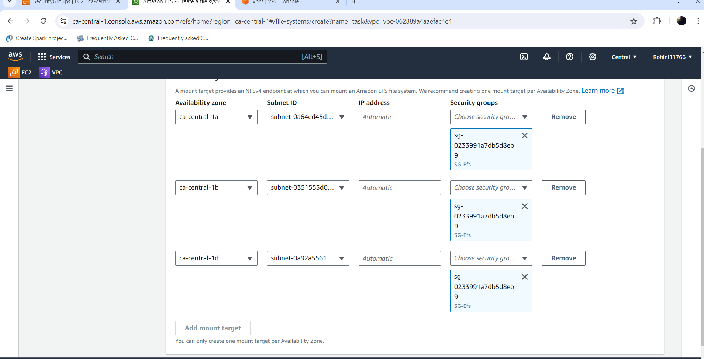

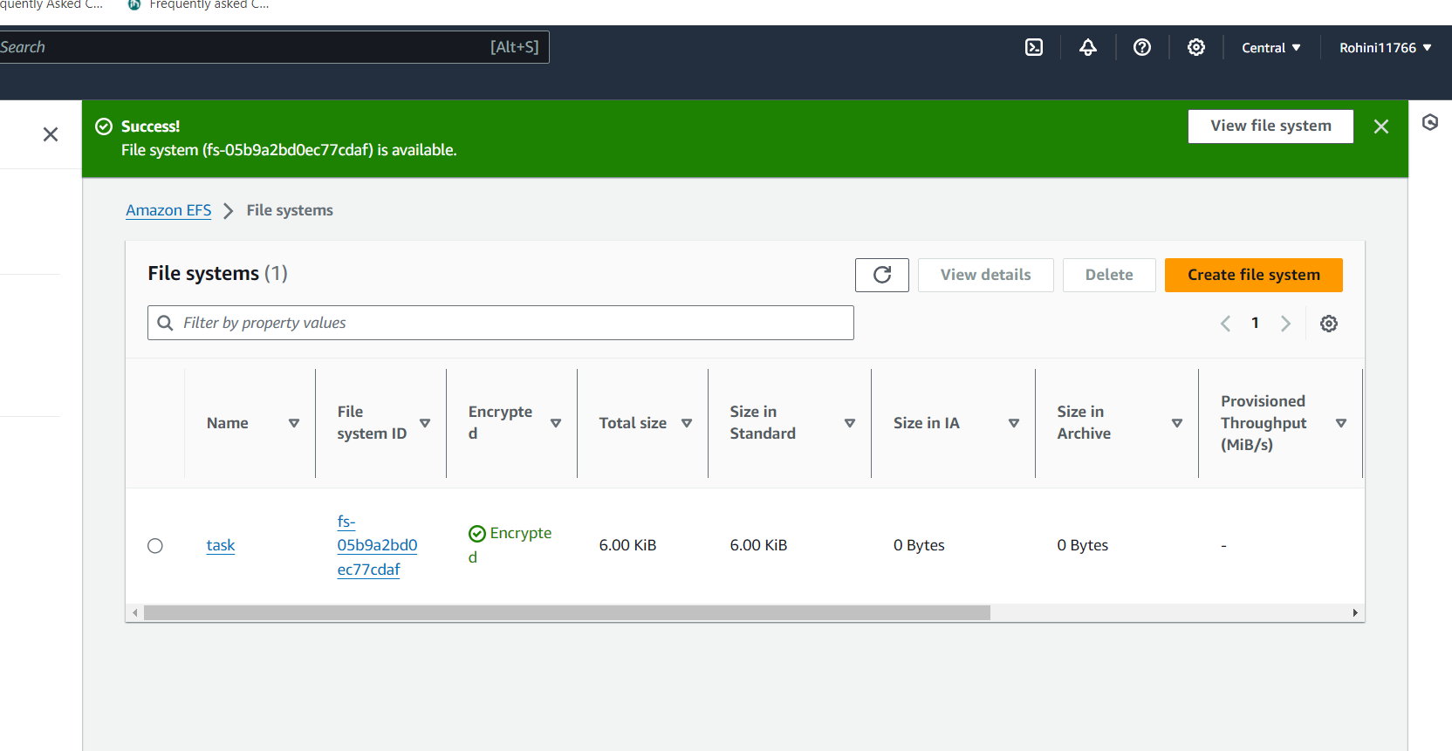

The EFS is created
Now launching the instance with the name ec1

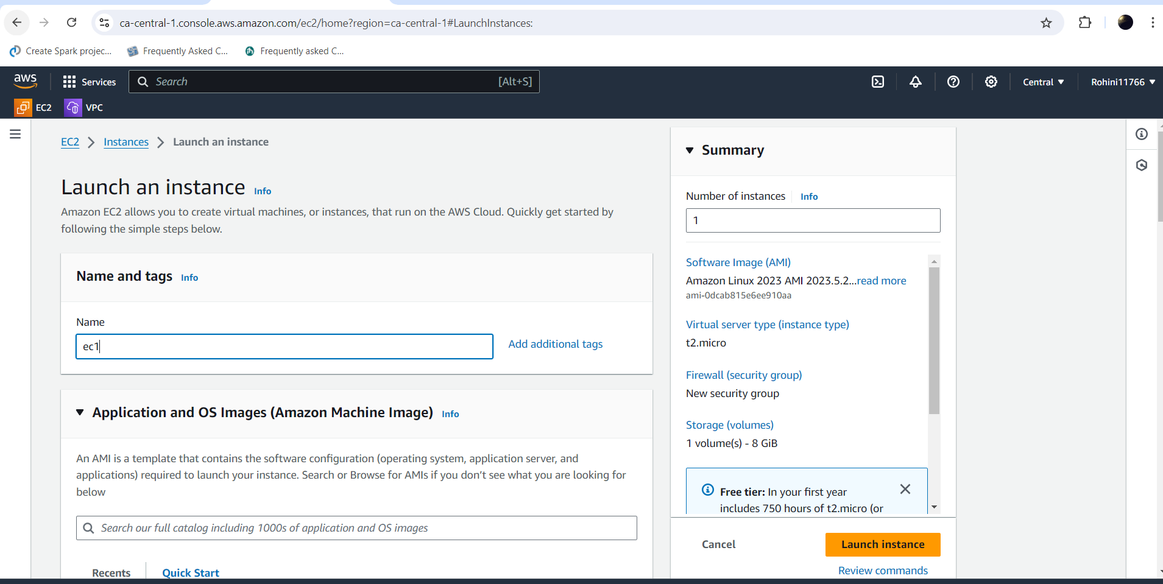
Select t2 micro give the keypair
Click on edit(networks)
Give the default vpc
Sleetc the existing security grp
Selecting the subnet as ca –central-1a

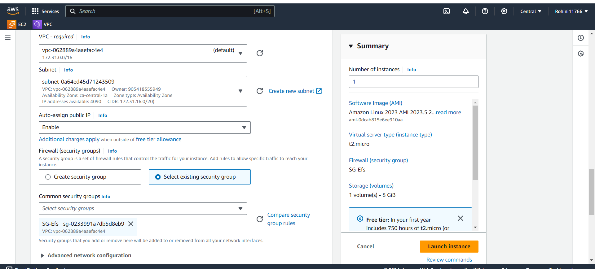
Click on file system and select the add shared file system
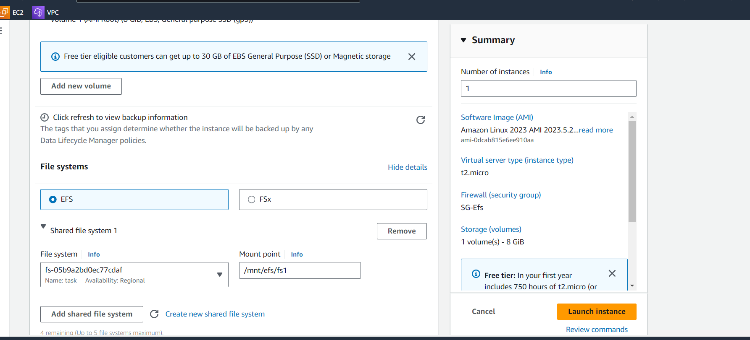

Launch the instance
And connect to the instance
Sudo –i
Cd /mnt/efs/fs1
Created a file with file name as file1
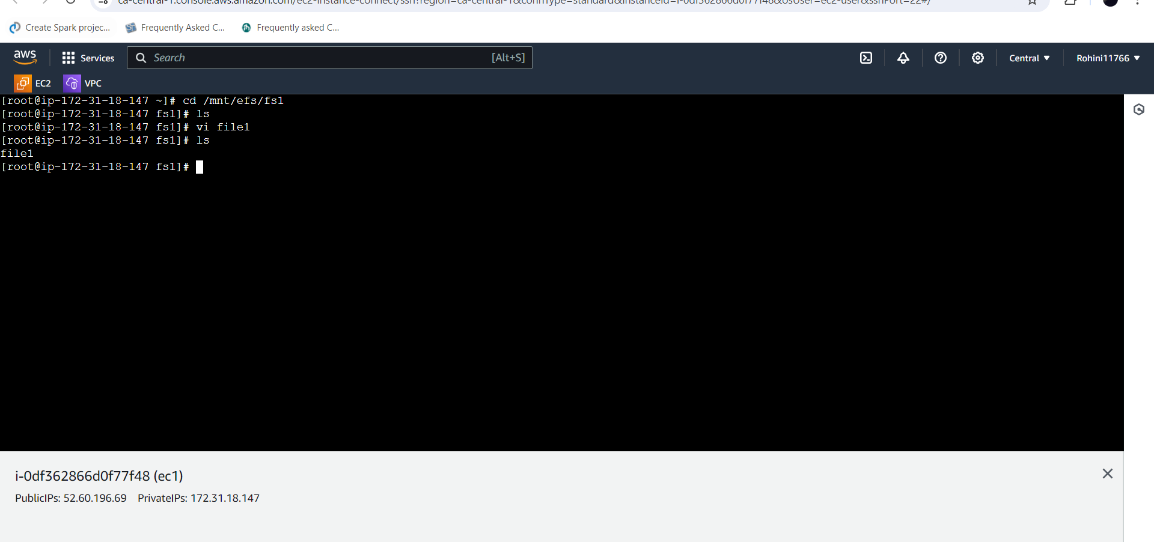
Second instance named as ec2 and selected the subnet as ca-central-1b
And launched the instance.
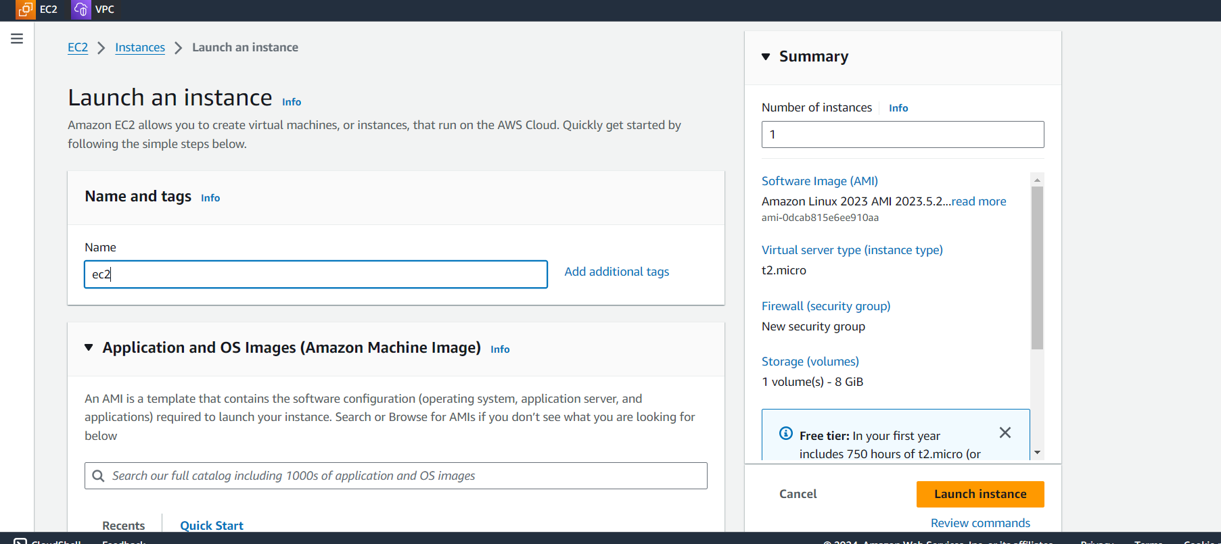
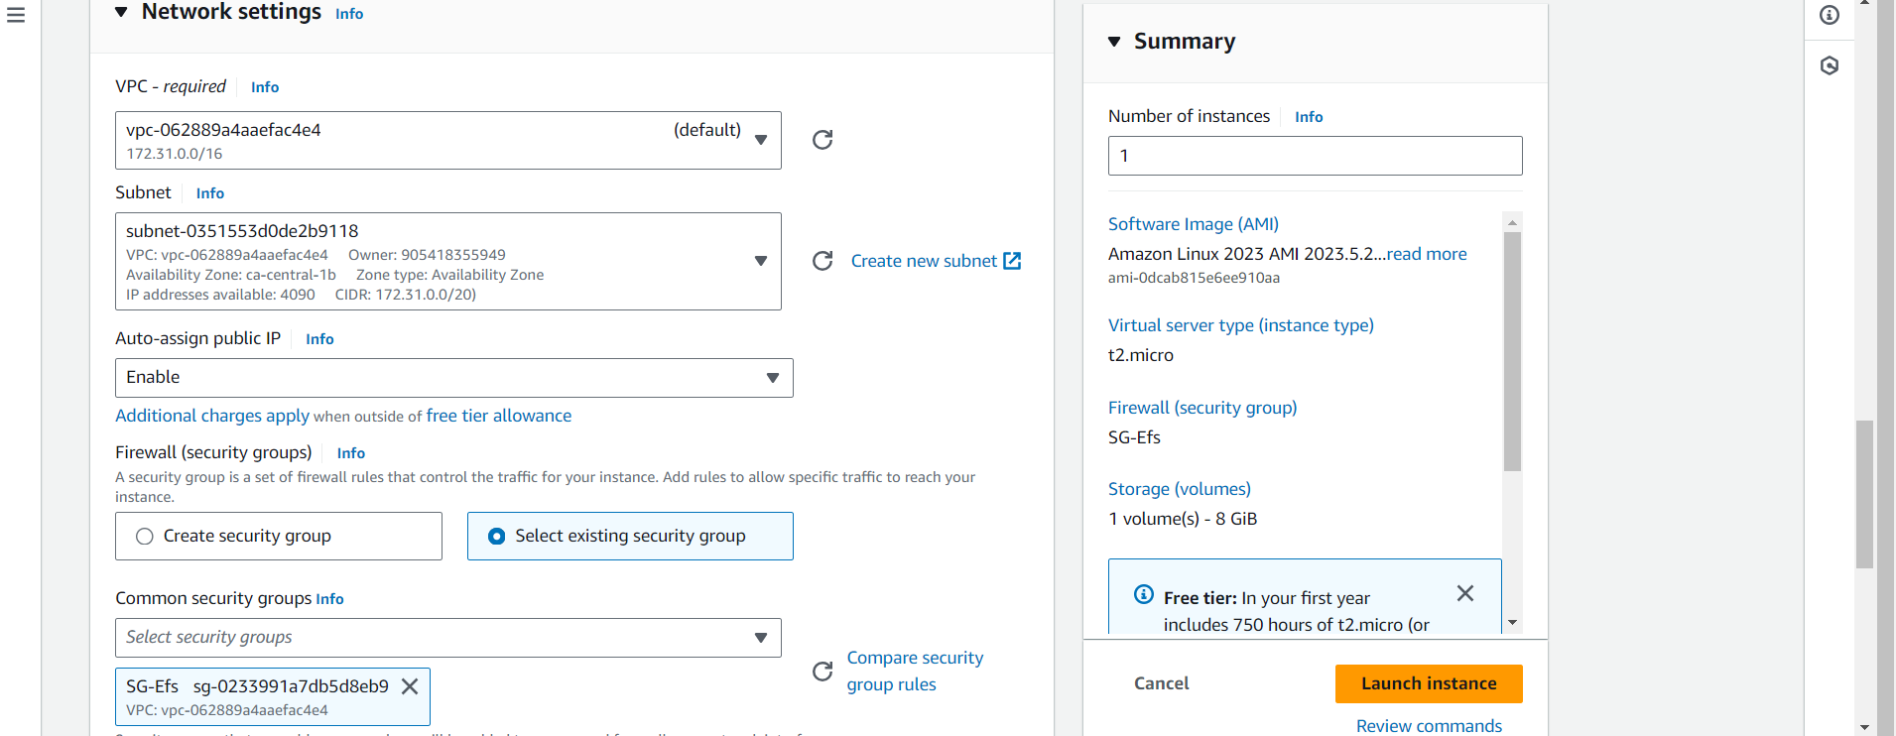

Connected to the instance
Sudo –i
Cd /mnt/efs/fs1
ls
now here we can see the file1 as we created the file in ec1 instance
createda file2 in ec2 instance

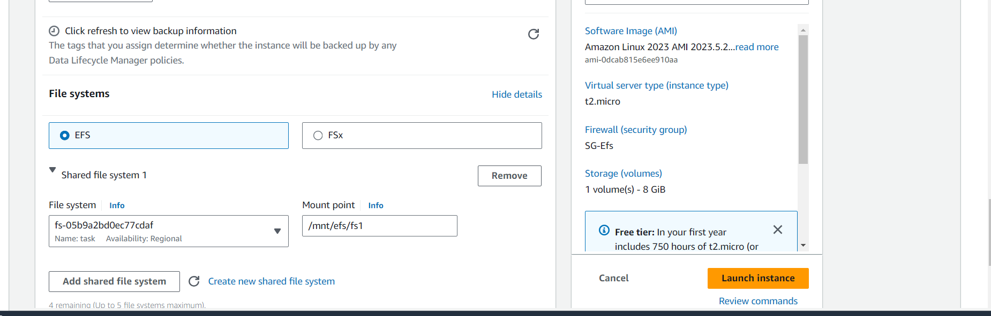
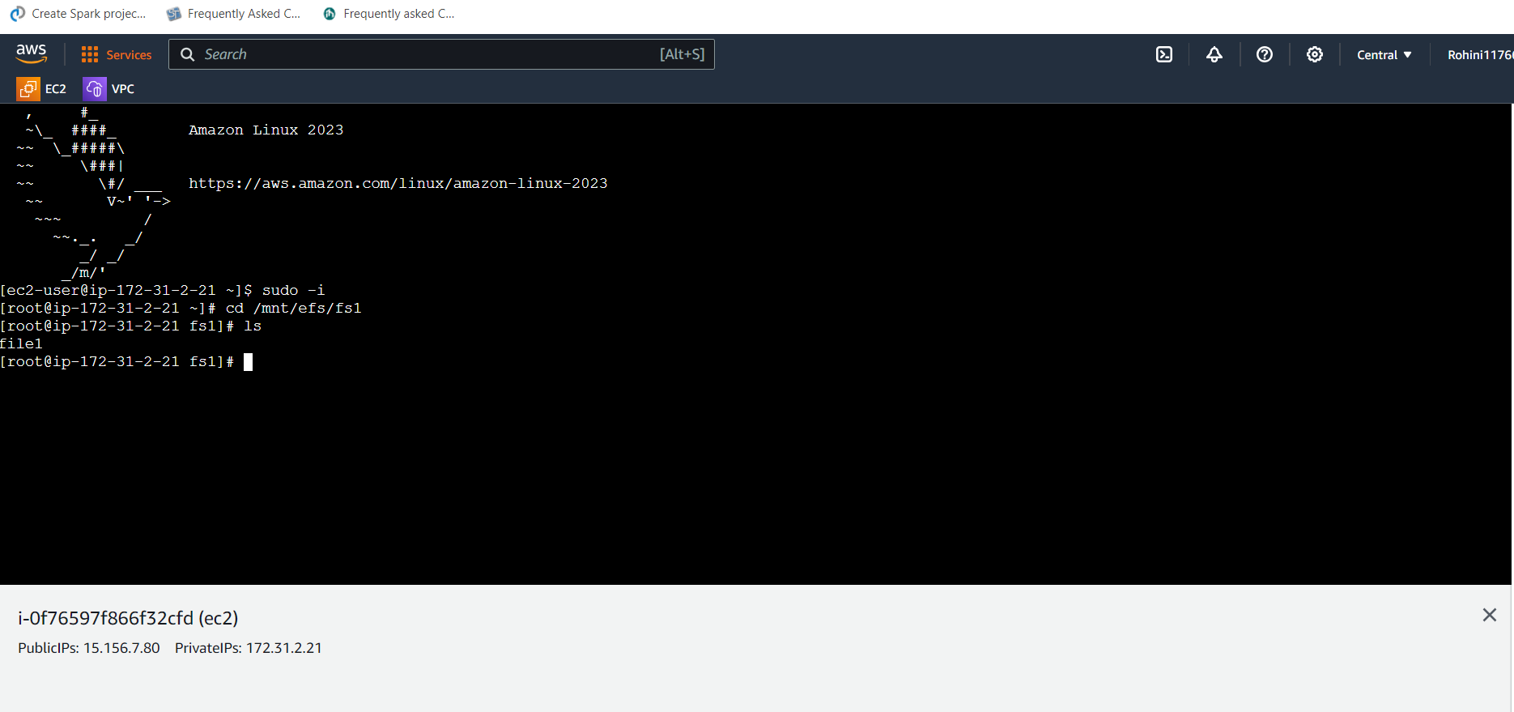

launched the instance ec3 in the zone ca-central-1d and connected to the instance.

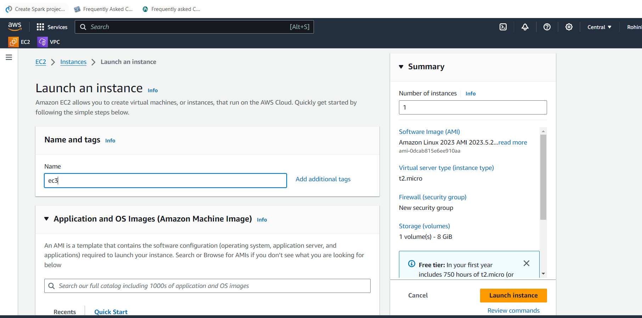

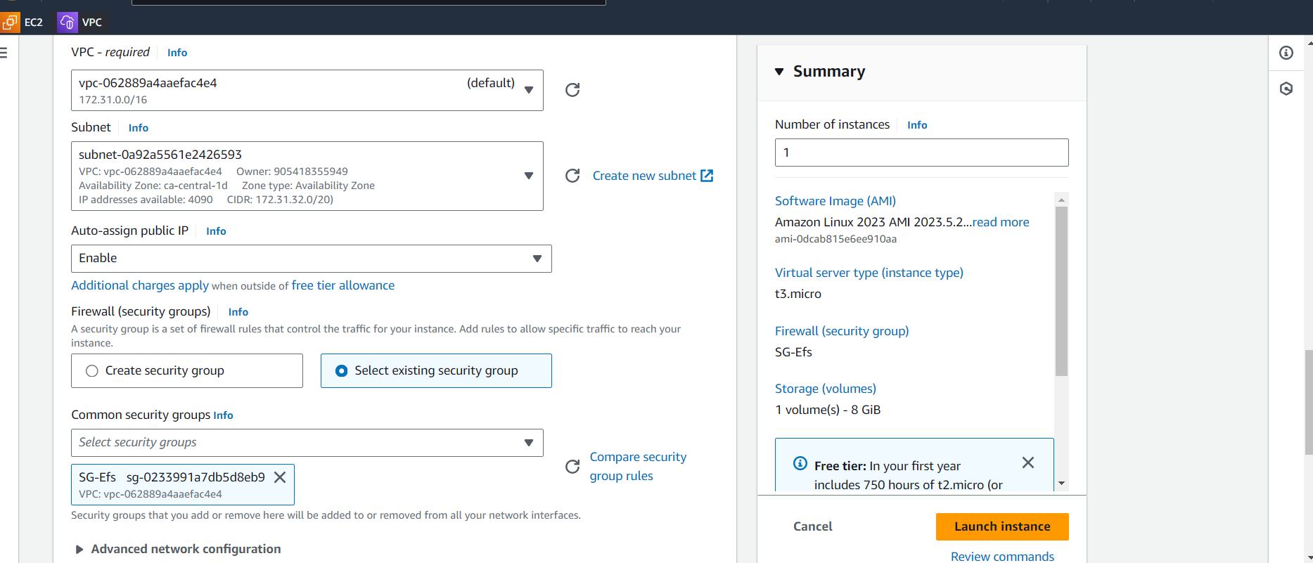

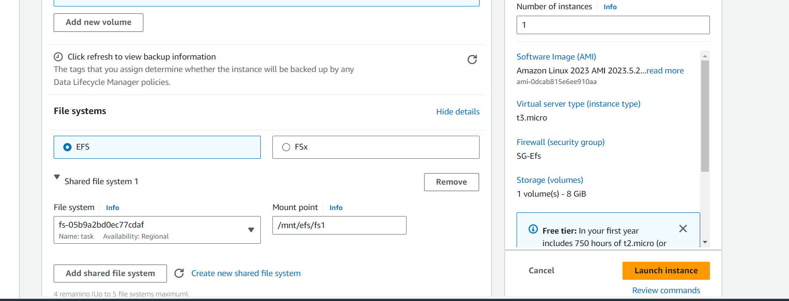

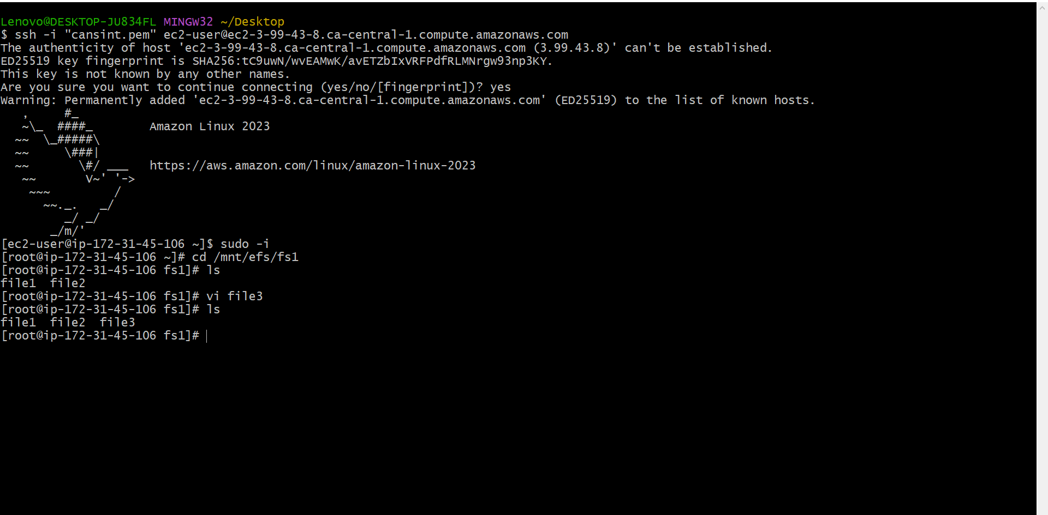

Sudo –i
Cd /mnt/efs/fs1
ls
we can see the file 1 and file 2 in the ec3 instance
now created the file 3 in instance ec3

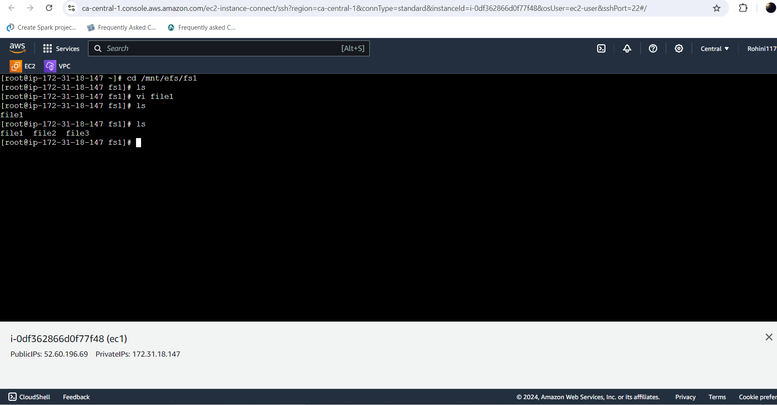

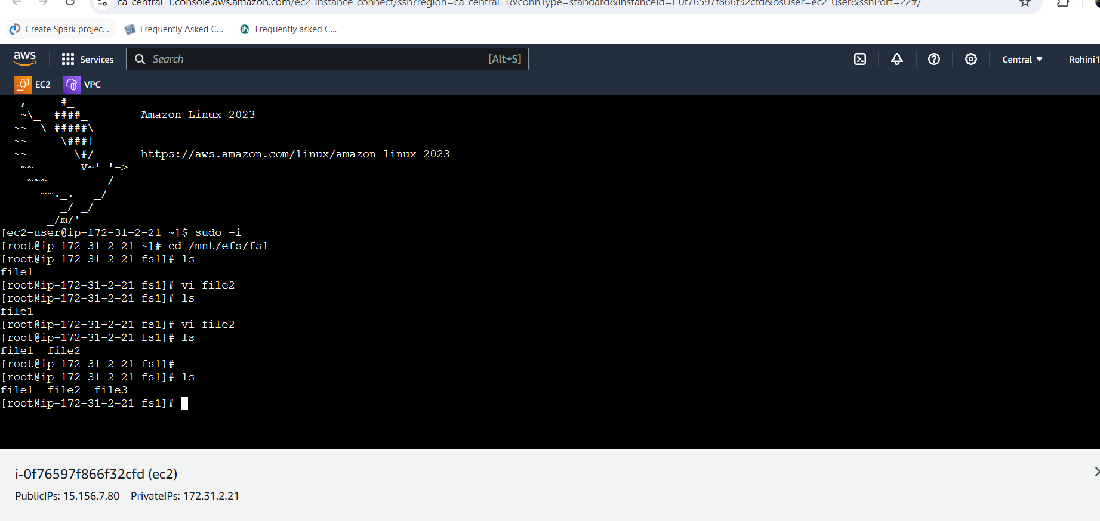
now we can this three files frm any instance (ec1,ec2,ec3)
We can see the file created on this server as well. This proves that our EFS is working.

